**MORNING CAR POOL PROCEDURES**

Cars enter Davis Drive Elementary from either Davis Drive or from Collins Road. There are two morning carpool lines.

1. The front entrance (From Davis Drive)
2. The back entrance (From Collins Road) ***This closes at 7:41 a.m., if you arrive at that time or later, please proceed to front entrance carpool.***

The entrances are designated by the location of where you live and are driving from to school.

* If you enter from Davis Drive, you must exit onto Davis Drive. **(A Carpool line)**
* If you enter from Collins Road, you must exit onto Collins Road. **(B Carpool line)**
* Cars entering from Collins Road (B Carpool line) MUST enter Davis Drive Elementary by turning right from Collins Road into Davis Drive parking lot.

***\*Please note if you are arriving at 7:44 a.m. or after you must park and walk with your child to sign him or her in at the office. He or she will be considered tardy.***

**A-DROP OFF FOR DAVIS DRIVE FRONT ENTRANCE**

1. Enter the parking lot from Davis Drive.

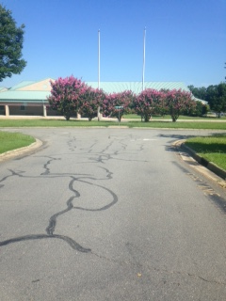

2. Follow the circle to the Drop off area at the front of the school.

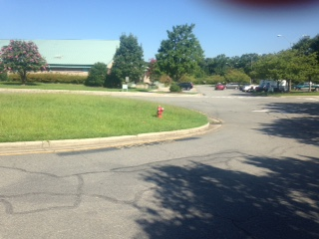

3. You will drop off at the front of the building.

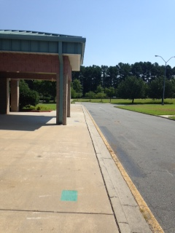

4. You will exit the drop off by making the first right in the circle and then head to Davis Drive.

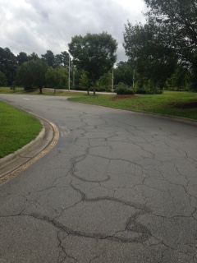

**B-DROP OFF PROCEDURES FROM COLLINS ROAD**

NOTE: ALL CARS will begin the drop off procedures turning right from Collins Road.

1. Turn right into Davis Drive Parking Lot from Collins Road.

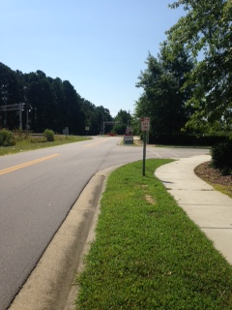

2. Then make the first right turn to drop off for the back entrance.

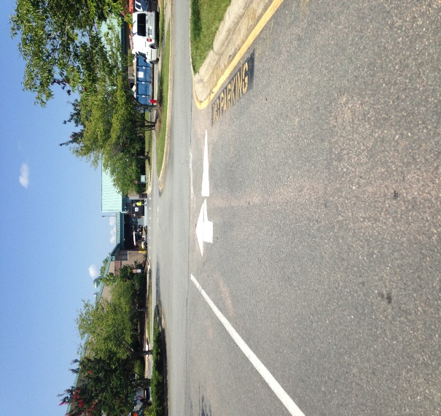

3. Follow the arrow straight through the parking lot.

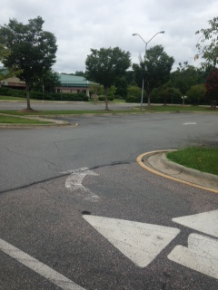

4. You will turn the curve and then drop off your student on the sidewalk at the back entrance to the school.

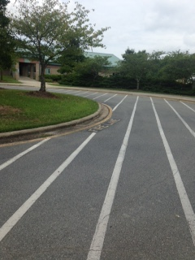

5. You will then proceed to exit the parking lot by making the first left to reach Collins Road.

